What is Operating System and functions of it?

Any software that controls hardware related to computer system is System software.

Any software that controls hardware related to electronic system is Embedded software.

OS is system software which controls all the hardware components of computer system when user working with computer system. OS provides an environment in computer system so that users can create and execute programs and can do some task in computer system. Through this Environment, OS acts as interface between user and Computer Hardware. Transfers users instructions to computer hardware and make different computer hardware work for user instructions.

OS is loaded into resident memory of RAM when it get booted.

The following are functions of OS:

1) Process management.

2) Memory management.

3) Disk management.

4) Device Management.

Above 4 are together called as resource management

5) Networking:

OS supports networking capabilities computer system like establishing and managing network connections, handling network protocols and sharing resources like printer in network.

6) User Interface.

7) Security:

OS provides secure environment policies and mechanisms like access controlling, encryption and decryption so that user data & information is secure in computer system.

8) Job Accounting:

OS keeps track of time and resources used by different programs and different users.

9) Performance monitoring:

OS provides tools for monitoring and optimising system performance.

Why and How OS is called resource controller and resource manager?

First OS is Batch OS.

Second OS is Uni programming OS:

In computer only one user works in computer and also executes only one program.

ex: MSDOS, Windows 3.1 etc

Third OS is Multi Programming OS:

In computer only one user works in computer and also executes multiple programs.

ex: Windows 95,98,millium etc

Fourth OS is Time Sharing OS:

It is also multiprogramming OS but interactive multiprogramming OS

Multiple users can access multiple programs in single computer

Multi processor OS:

>One user can execute multiple programs at a time by using multiple CPU's

EX: Windows NT, Windows EP, Sandy Bridge, Veckton

Shell is interacts with user. It has built in program called commands through which user interact with shell. Commands are also called as Utilities.

Kernel is component which interacts with hardware and instructs the hardware to fulfil user need.

System calls are built in programs in OS which transfers information from shell to kernel and kernel to shell.

What is difference b/w 32 bit and 64 bit CPU?

In C:

pointers, structures, arrays, string, macros

OOPS concept:

C++,Java

Data Structures, OS, CN,SE,DBMS

\*Distributed Operating OS:

EX: Ameba, Chameleon

\*Real Time OS:

>Executes tasks & Programs with timing constraints

>These are used to implement traffic control systems ,robots , automatic , airbags automatic parachutes

\*What is Process In OS?

>A Process is a program in execution means a set of instructions loaded in memory and executed by CPU and IO processor . Generally when we develop a program first we create source code in the form of file then we compile and generate machine code also in the form of file . The source code file and machine code file placed in computer system storage file . This machine code file in storage disk is called program . When we start executing the program the machine disk file is transfer and loaded into main memory RAM by os with the help of loader.Once loaded into memory it is called process thus program is static entity process is dynamic entity.Once execution of process is completed it is cleared in main memory that means process has life includes beginning and termination.

\*Diff BW process and program?

\*which data structure os uses to control the execution of process?

>OS creates a data structure called PCB when process is created and using this DS it controls execution of process this DS PCB contains information about process and resources it is using for execution this is also called process control block (PCB) . The following are the contents of pointers.

Registers inside CPU:

> MAR - Memory address registers

> MBR - Memory buffer registers.

> General Purpose Registers .

>Accumulator

\*what is PCB and what are components of PCB:

> It is a pointer to stack memory which contains information about the process switched from one state to another state.

Process States:

>New

>ready

>Running

>Sleep

>Waiting

>Terminated

>Block

Program Counter:

>The program counter (PC), also sometimes called the instruction pointer (IP) or instruction address register (IAR), is a crucial register within the Central Processing Unit (CPU) of a computer

\*What is process life cycle?

\*what is mean by context switching ?

>In multi programming when a process is executing its information like instructions data are place in registers of CPU . When corrently running process moves to IO state then all the information of CPU registres placed in PCB ,CPU registers are cleared and When Cpu is awarded with next process the registers awarded with next process.When CPU is allocated to previous process again the information from PCB is reloaded in CPU registers and process execution is resumed from last point this called context switching .

\*If c program executes as collection of process using collection context switching ....?

>

\*What are the benifits of multi programmin?

> We can increase throw put .

> Efficiant use of utiligation .

> Increasing responsiveness .

\*Without CPU sheduling can multiprogrammin servive ?

\*What are the basic types CPU sheduling ?

\*Advantages of CPU scheduling.

>Increases throw

>Avoid and reduces CPU Time

\*Types of schedulers:

In OS there is a built program called scheduler which is available in three types

1. Long term scheduler: Long Term scheduler schedules a job into ready queue when it is created.
2. Short term scheduler :It is also called CPU scheduler.
3. Medium term scheduler :It is also called IO scheduler schedules a process to IO state.

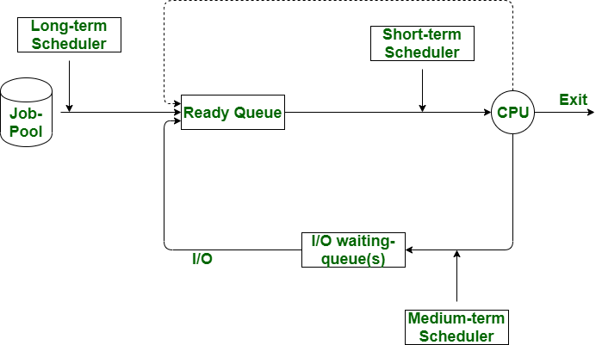

CPU Scheduling algorithm:

It is built in program which is used to control allocation of CPU different processors at different time.

There are 2 types of CPU scheduling algorithm:

1. Preemptive Scheduling Algorithm
2. Non Preemptive Scheduling Algorithm

In case of Non preemptive CPU scheduling algorithm, Cpu is allocated next process only when currently running process either terminates or moves to I/O.

This is irrespective of how much currently running process uses CPU. Generally this algorithm is there in Multi Programming OS

Ex: Windows, Mackintosh etc

In case of preemptive CPU scheduling algorithm, Cpu is allocated for next process in ready queue when either time slice is completed or I/O is required or process is terminated. At the end of each time slice CPU is switched next process.

What do you mean by CPU bound and I/O bound process?

CPU bound process means it requires more CPU operations and very less I/O operations in fact in some case none. In Non preemptive Cpu scheduling because of CPU bound process the execution of other becomes late.

I/O bound process contains more I/O operations and less CPU operations because of I/O bound process sometimes CPU get wasted (CPU utilisation is low).

Algorithms of Non Preemptive Cpu scheduling:

1. Shortest job first
2. Priority Cpu scheduling
3. Longest job first
4. First come first serve

Algorithms of Preemptive Cpu scheduling:

1. Round robin
2. Shortest Remaining time first(SRTF)
3. Longest remaining time next(LRT)
4. Highest Response ratio next(HRRN)

Now modern OS are using new algorithm which is called Multilevel feedback queue. This can both preemptive and non preemptive.

Refer <https://www.educative.io/answers/what-is-multilevel-feedback-queue-scheduling> for diagrammatic explanation.

CPU schedulind cretia:

1. Arrival Time (AT):

The time at which a process arrives in the ready queue. This is the time when the process is ready to start execution.

1. Burst Time (BT):

The total time required by a process for its execution on the CPU. It is also known as execution time or run time.

1. Waiting Time (WT):

The total time a process spends in the ready queue waiting for its turn to get executed by the CPU. It is calculated as:

WT=TAT−BT

1. Turnaround Time (TAT):

The total time taken for a process to complete, from the moment it is submitted until it finishes execution. It includes both the waiting time and the burst time. It is calculated as:

TAT=CT−AT

1. Completion Time (CT):

The time at which a process completes its execution and exits the system.

Interprocess communication in OS:

It is required among two or more for sharing resources without conflicts.if resources are shared with conflicts then either resources are damaged or otput is incorrect. In multi programming OS,there are 2 types of processes:

1. Independent process
2. Coopeartive process

Independent process is process which executes independently without sharing resources with others.They donot require IPC

Co-operative process requires IPC as they executes with sharing resources like file, i/o etc with others.

IPC techniques in DBMS are 2PL and time stamping algorithm

IPC techniques in OS:

1. Mutual inclusion.